Email Marketing & CRM Automation
Dentist Lead Automation System
-------------------------------------------------------------------------------------------------------
ActiveCampaign • Make.com • Atlas AI • Cal.com • WhatsApp

Dentist Lead Conversion & Booking System Project Documentation v1.0

Client | HALIMSBENATI
Date | 23 April 2026
Version | 1.0
Status | Active all automations live
Platforms | ActiveCampaign · Make.com · Atlas AI · Cal.com · WhatsApp Business
System Type | Dentist Lead Conversion, AI Calling & Appointment Booking Automation

1 | Project Overview  What the system does and why it was built

This document describes the complete lead automation system built for HALIMSBENATI using ActiveCampaign, Make.com, Atlas AI Agent, Cal.com, and WhatsApp. The system is designed to automatically engage new dentist leads, nurture non-bookers into scheduling a discovery call, and welcome confirmed bookers all without manual intervention.

System Goal: When a lead fills out the intake form (Name, Email, Phone), they are automatically added to ActiveCampaign with a dentist tag and enrolled in a multi-touch follow-up sequence. The system attempts to convert non-bookers into discovery call attendees using AI-powered voice calls and WhatsApp messages over a 10-day window and ensures bookers show up by sending timed WhatsApp reminders.

1.1 Tools & Platforms
Platform | Role & Reference
ActiveCampaign | CRM, contact management, email automations halimsbenati.activehosted.com
Make.com | Automation middleware triggers, WhatsApp messaging, Atlas API calls
Atlas AI Agent | AI outbound calling platform app.youratlas.com
Cal.com | Booking calendar discovery call scheduling
WhatsApp Business | Messaging channel delivered via Make.com integration

2 | System Architecture  End-to-end flow overview

The system consists of four interconnected layers: the lead intake form, ActiveCampaign automations, Make.com scenarios, and external services (Atlas AI + WhatsApp). Each layer communicates with the next via webhooks and API calls.

Complete System Flow
1  Lead Fills Form | 2  ActiveCampaign Tags Contact | 3  Automation A Starts | 4  Make.com Triggers Atlas + WhatsApp | 5  Lead Books via Cal.com | 6  Automation B + Reminders

Detailed End-to-End Flow
- Lead fills intake form → Contact created in ActiveCampaign with tag: dentist
- Automation A triggers → 5-min initial wait → Non-booker condition check
- If non-booker → Make.com fires Atlas AI call + WhatsApp → waits → repeats for 6 rounds over 10 days
- If lead books via Cal.com → Make.com Discovery Call Booking workflow fires → tag discovery_call_booked is added to contact
- Automation A stops → tag condition exits the lead from the non-booker sequence
- Automation B triggers → Welcome Atlas AI call + WhatsApp confirmation sent
- Reminder workflows run → WhatsApp alerts sent 24 hours, 1 hour, and 15 minutes before the call

3 | Lead Intake Form  Entry point ActiveCampaign hosted form

The entry point of the entire automation system is a simple web form hosted on ActiveCampaign. When a potential dentist lead fills out this form, they are automatically created as a contact in ActiveCampaign with the dentist tag applied, triggering all downstream automations immediately.

Form URL: https://halimsbenati.activehosted.com/f/3

Form Fields
Field | Type & Purpose
Full Name | Text (required) stored as contact first/last name in ActiveCampaign
Email Address | Email (required) primary identifier; used for all ActiveCampaign lookups
Phone Number | Phone with flag (required) Pakistani flag (+92) default; used for WhatsApp & Atlas AI calls

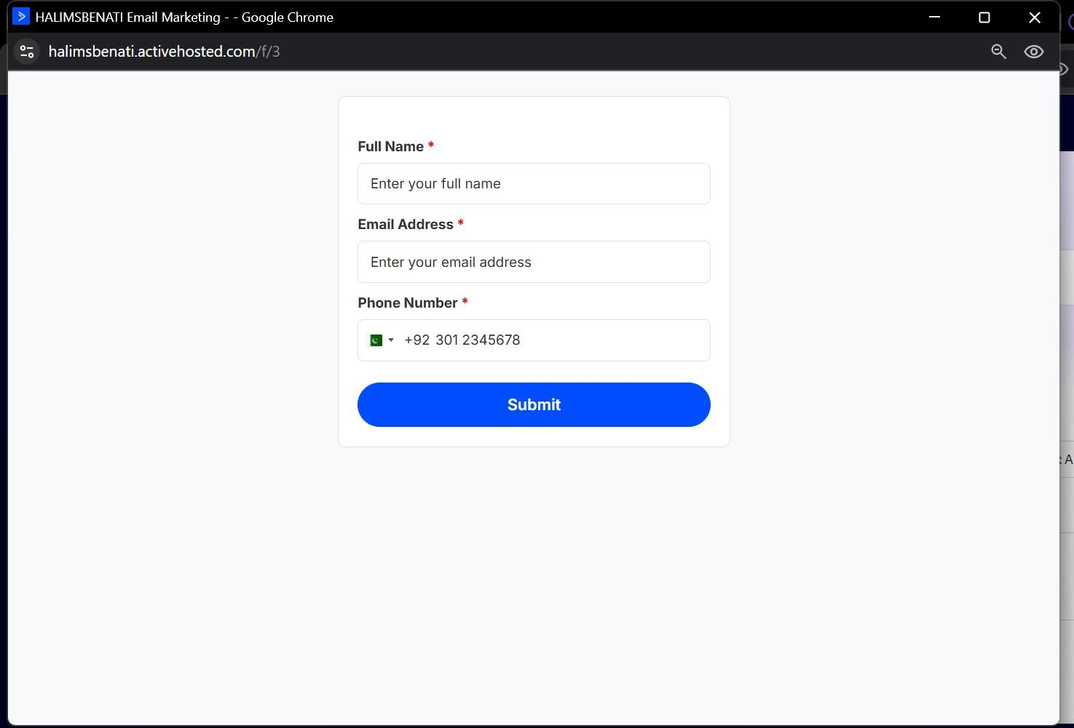

4 | Automation A Non-Booker Follow-Up (Dentist)  ActiveCampaign · 10-day nurture sequence

Automation A is the primary nurture automation. Its purpose is to repeatedly engage leads who have not yet booked a discovery call and convert them into bookers over a structured 10-day sequence of AI voice calls and WhatsApp messages. The automation exits immediately as soon as the lead books.

Trigger Conditions
Trigger | Condition
Primary Trigger | Contact submits the intake form → dentist tag is applied → Automation A starts immediately
Secondary Trigger | Tag dentist is added to an existing contact (manual or via other automations)
Third Trigger | Contact subscribes to the Overseas Dentist list

Tags Used
Tag | Purpose / Behaviour
dentist | Entry tag identifies the contact as a dentist lead; triggers Automation A
discovery_call_booked | Exit condition when this tag exists, the automation stops all further outreach

Conditional Logic at Every Step
At each touchpoint before any action is taken, the automation checks: Does the contact have the tag 'discovery_call_booked'? YES → Contact has booked exit the automation immediately. No further outreach. NO → Contact is still a non-booker continue with the scheduled outreach.

Follow-Up Schedule 6 Rounds Over 10 Days
Each round consists of an AI voice call via Atlas Agent (triggered through Make.com) and a WhatsApp message (also via Make.com). Wait times between rounds increase progressively.

Round | Wait | Condition Check | AI Voice Call | WhatsApp Message
1 | 5 min (initial) | Non-booker check | ✓ Non-Booker Follow-Up campaign | (no WhatsApp round 1)
2 | 1 hour | Non-booker check | ✓ Non-Booker Follow-Up campaign | ✓ Sent via Make.com
3 | 1 day | Non-booker check | ✓ Non-Booker Follow-Up campaign | ✓ Sent via Make.com
4 | 2 days | Non-booker check | ✓ Non-Booker Follow-Up campaign | ✓ Sent via Make.com
5 | 2 days | Non-booker check | ✓ Non-Booker Follow-Up campaign | ✓ Sent via Make.com
6 | 2 days | Non-booker check | ✓ Non-Booker Follow-Up campaign | ✓ Sent via Make.com
7 | 3 days | Non-booker check | ✓ Non-Booker Follow-Up campaign | ✓ Sent via Make.com

How Outreach Is Triggered
AI Phone Call (Atlas Agent via Make.com)
- ActiveCampaign triggers a Make.com webhook URL at each round
- Make.com calls the Atlas Agent API with the contact's phone number
- Atlas Agent places an outbound AI voice call to the lead
- Call objective: Persuade the lead to book a discovery call
- Atlas Campaign: Non-Booker Follow-Up

WhatsApp Message (via Make.com)
- A separate Make.com webhook is triggered by ActiveCampaign alongside the AI call
- Make.com sends a WhatsApp template message to the lead's phone number via WhatsApp Business Cloud
- Message content includes a direct link to the Cal.com booking page

Automation A Screenshots
Full automation overview (zoomed out):
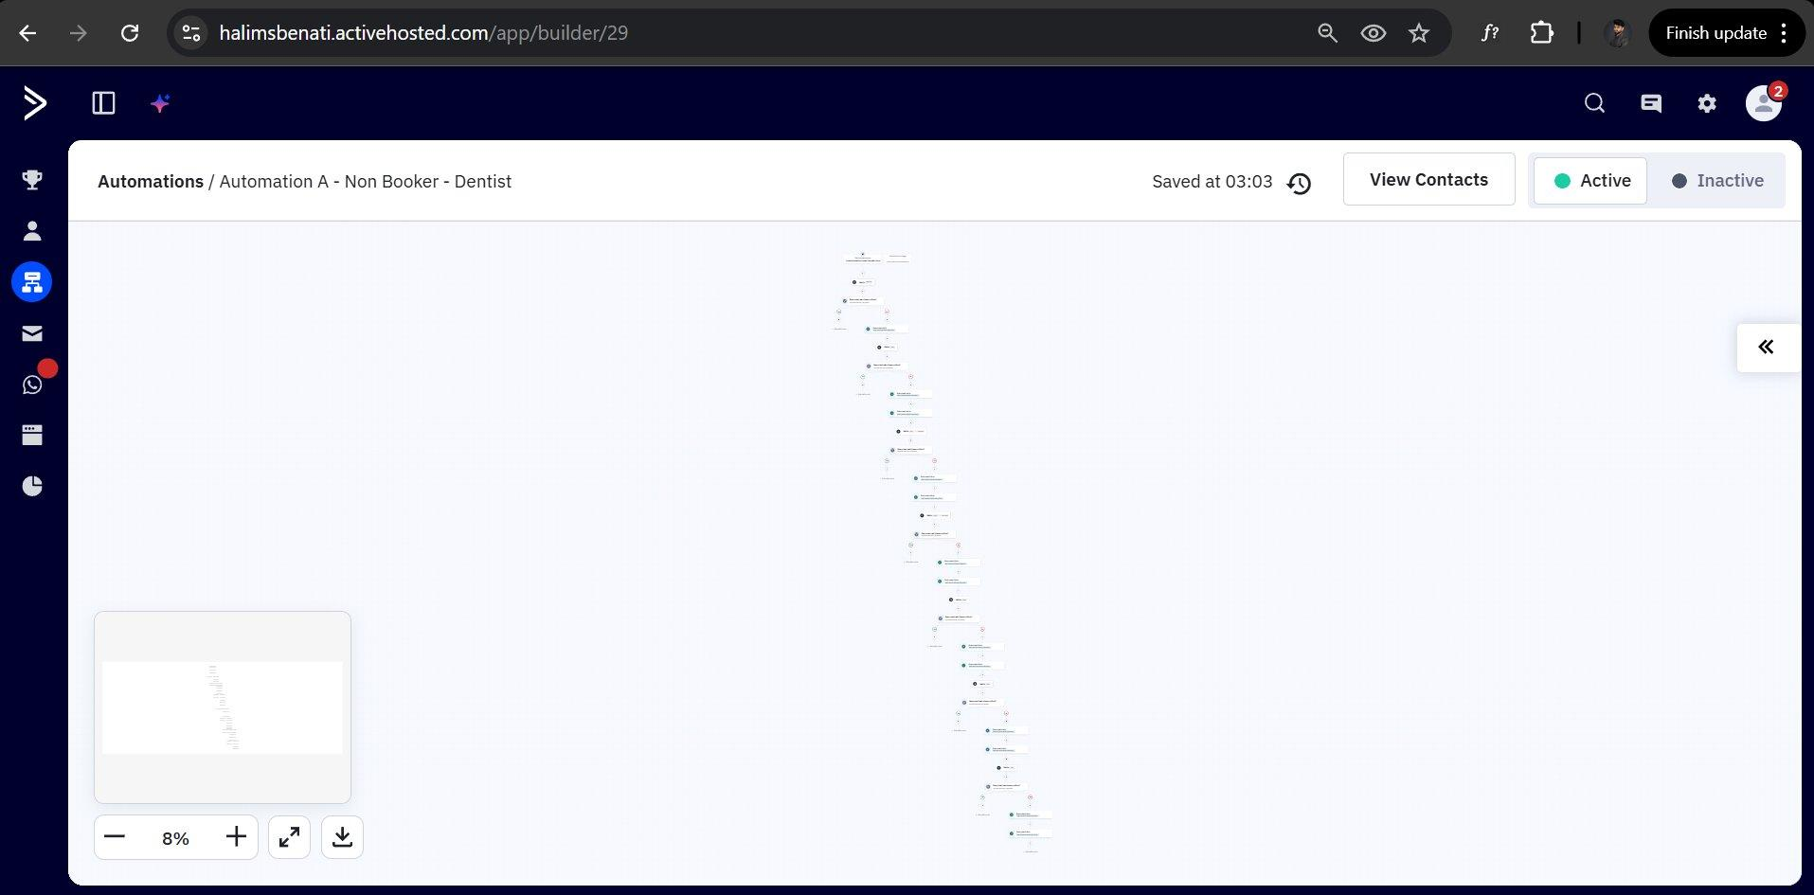

Automation A detailed view showing triggers and first steps:
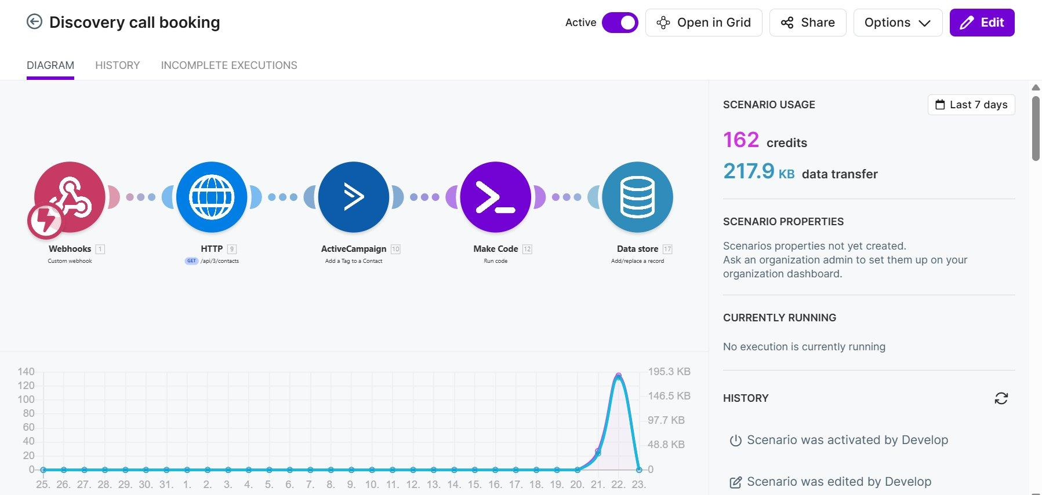

5 | Make.com Discovery Call Booking Workflow  Cal.com → ActiveCampaign → Data Store

This Make.com scenario is responsible for detecting when a lead books a discovery call on Cal.com, updating their ActiveCampaign record with the booking tag, and storing all booking data for the three reminder workflows to use.

Make.com Scenario URL: https://us2.make.com/354077/scenarios/4818196/edit

Trigger
Parameter | Value
Platform | Cal.com
Event | booking.created fires when a new appointment is confirmed on the client's calendar
Method | Cal.com sends a webhook POST payload to the Make.com custom webhook URL

Workflow Steps
Step | Action & Purpose
Step 1 Webhook Trigger | Make.com listens for the booking.created event from Cal.com via a custom webhook
Step 2 Search Contact (HTTP) | HTTP GET request to ActiveCampaign API (/api/3/contacts) to find the contact by email returns their unique Contact ID
Step 3 Add Tag (ActiveCampaign) | ActiveCampaign 'Add Tag to Contact' module applies the discovery_call_booked tag this immediately stops Automation A
Step 4 Run Code (Make Code) | A JavaScript code module normalises and formats the booking data before storing
Step 5 Data Store (Add/Replace) | All booking data is stored in a Make.com Data Store keyed by contact email used by all three reminder workflows

Data Stored (Used by Reminder Workflows)
Data Field | Purpose
Contact name | Full name for personalisation in WhatsApp messages
Email address | Primary key for Data Store record
Phone number | Destination for WhatsApp reminders
Scheduled call date | Date of the confirmed discovery call
Scheduled call time | Time of the call compared at runtime by each reminder workflow
Booking ID | Cal.com booking reference
Timestamp | When the booking was created

Workflow Screenshot


6 | Make.com WhatsApp Reminder Workflows  3 timed reminders before the discovery call

Three separate Make.com scenarios handle WhatsApp reminders before the scheduled discovery call. Each workflow runs on a 15-minute polling schedule, reads booking records from the Make.com Data Store, and sends a WhatsApp template message when the timing window is reached.

Workflow Name | Poll Schedule | Trigger Condition | Make.com URL
24hr Reminders | Every 15 minutes | 24 hours before scheduled call | us2.make.com/354077/scenarios/4827383/edit
1H Reminders | Every 15 minutes | 1 hour before scheduled call | us2.make.com/354077/scenarios/4827454/edit
15min Reminders | Every 15 minutes | 15 minutes before scheduled call | us2.make.com/354077/scenarios/4827488/edit

How Each Reminder Workflow Operates
- Scenario runs on a scheduled trigger every 15 minutes
- Data Store (Search records) searches all booking records in the Make.com Data Store
- Time check: filters records where the time remaining until the call matches the reminder window (24h / 1h / 15min)
- WhatsApp Business Cloud sends the approved WhatsApp template message to the lead's phone number with call details

Reminder Workflow Architecture (all three are identical in structure)
Data store  Search records [1] | → | WhatsApp Business Cloud  Send a Template Message [2]

Reminder Screenshots
24-Hour Reminder (24HReminders):
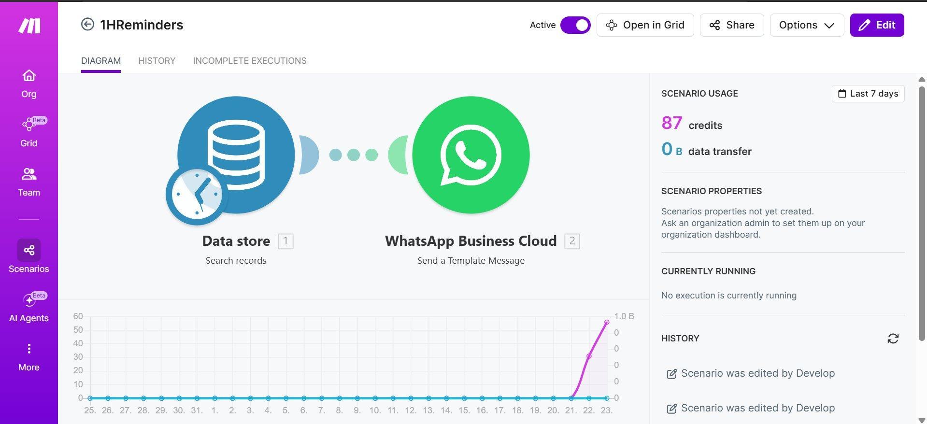

1-Hour Reminder (1HReminders):
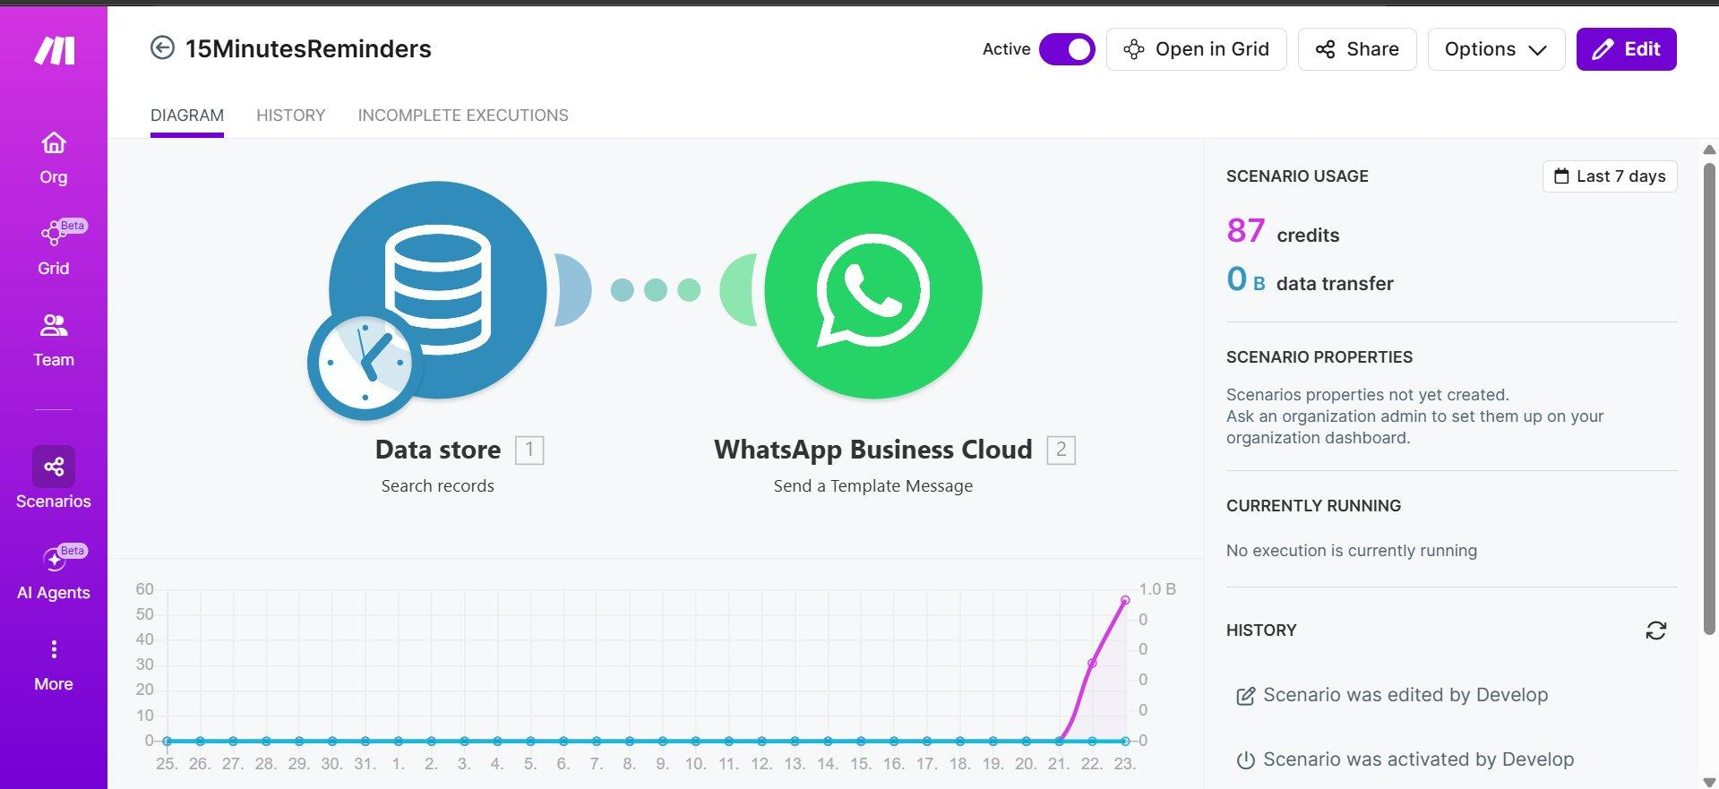

15-Minute Reminder (15MinutesReminders):
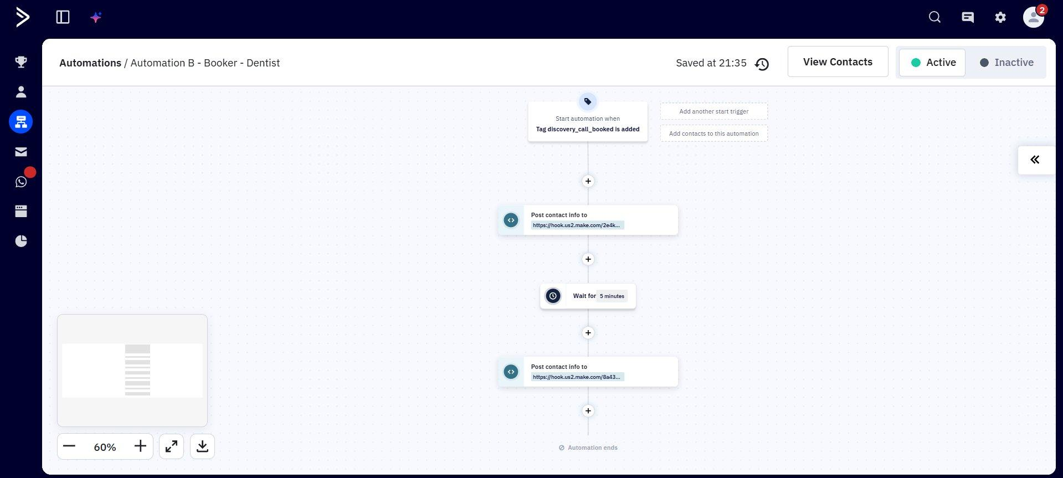

7 | Automation B Booker Welcome Follow-Up (Dentist)  ActiveCampaign · Confirmation + show-up sequence

Once a lead has booked a discovery call, they are automatically moved into Automation B a welcome and confirmation sequence. Its purpose is to confirm the booking, build rapport, and maximise the likelihood that the lead actually shows up for their scheduled call.

Trigger
Parameter | Value
Tag | discovery_call_booked is added to the contact
Applied by | Make.com Discovery Call Booking workflow (Section 5) fires immediately on Cal.com booking.created event
Automation B starts | Immediately upon tag assignment runs in parallel with the reminder workflows

Automation Steps
Step | Action & Detail
Step 1 Post to Make.com Webhook #1 | Triggers the first Make.com webhook URL (hook.us2.make.com/2e4k...) fires Atlas AI Welcome Call (Booker Welcome Follow-Up campaign)
Step 2 Wait 5 Minutes | Brief delay to ensure contact data is fully updated in ActiveCampaign before second outreach begins
Step 3 Post to Make.com Webhook #2 | Triggers a second Make.com webhook URL (hook.us2.make.com/8a43...) sends a WhatsApp welcome/confirmation message to the lead
Step 4 Automation ends | No further steps the Reminder workflows (Section 6) independently handle the timed pre-call WhatsApp alerts

Atlas Campaign Used in Automation B
Campaign Name | Purpose
Booker Welcome Follow-Up | Outbound AI call congratulates the lead on booking, confirms their appointment time, and sets expectations for the discovery call

Automation B Screenshots
Close-up view trigger and first steps:
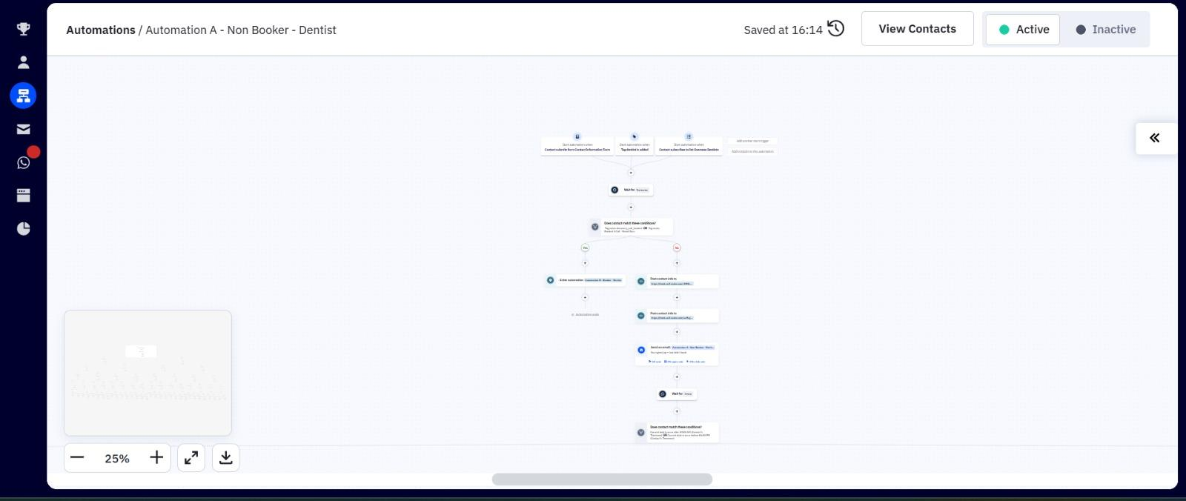

Full automation view (25% zoom):
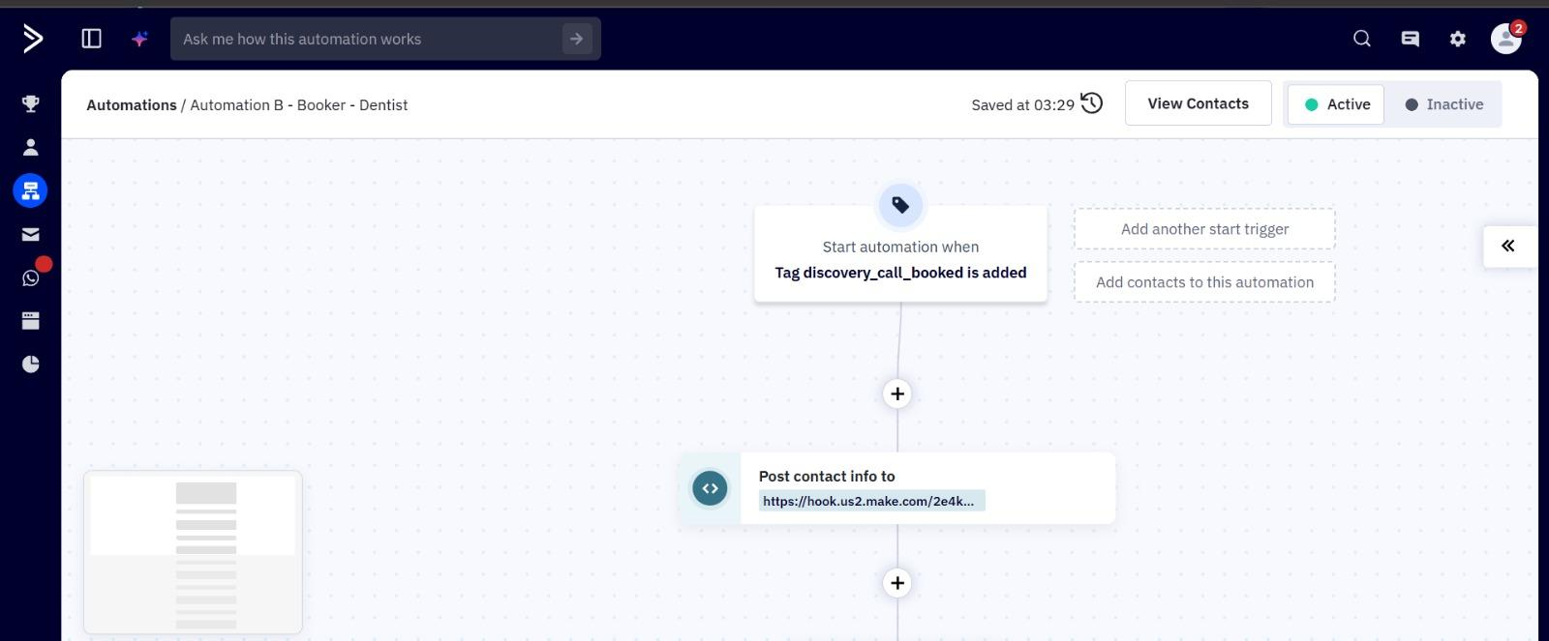

8 | Make.com ActiveCampaign to WhatsApp Scenarios  Non-booker WhatsApp message sequences

The ActivecompaigntoWhatsapp folder in Make.com contains all the individual WhatsApp message scenarios triggered by Automation A. Each scenario is activated by a webhook from ActiveCampaign at the corresponding round, and sends a specific WhatsApp template message to the lead.

Scenario Name | Round & Usage Stats
not_booked_first_message | Round 1 first WhatsApp message to the non-booker 230 operations · 31.2 KB
not_booked_second_message | Round 2 second WhatsApp message 217 operations · 29.4 KB
not_booked_fourth_message | Round 4 fourth WhatsApp message 183 operations · 25.1 KB
not_booked_fifth_message | Round 5 fifth WhatsApp message 183 operations · 25.8 KB
not_booked_sixth_message | Round 6 sixth WhatsApp message 175 operations · 22.3 KB

Each scenario in this folder follows the same pattern: ActiveCampaign webhook → router/sleep module → WhatsApp Business Cloud 'Send a Template Message'. The router and sleep ensure messages are not sent outside acceptable hours.

Make.com Scenarios Screenshot
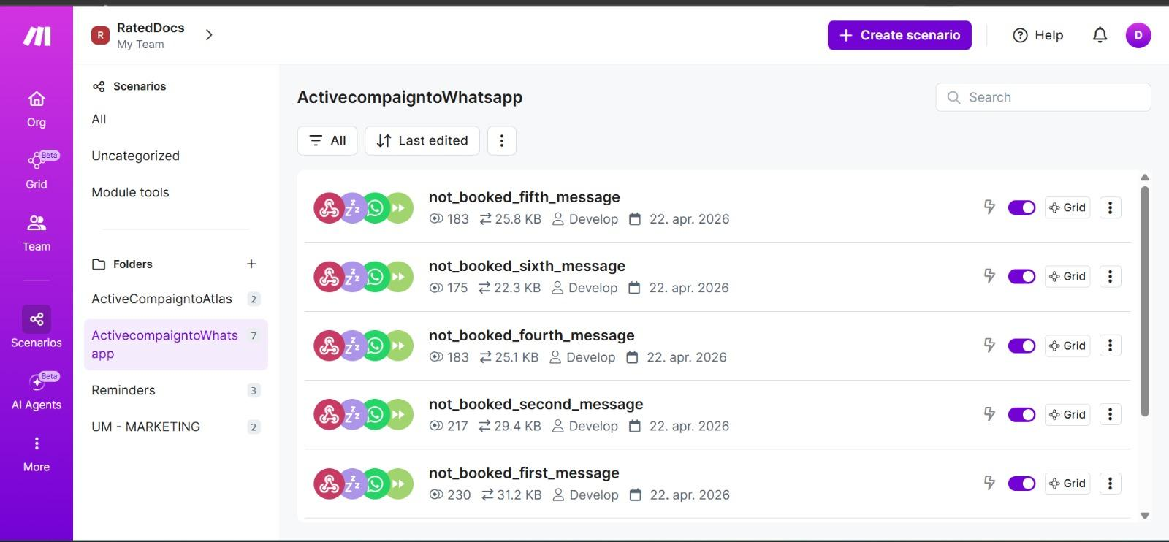

9 | Atlas AI Agent Outbound Voice Calling  AI-powered phone calls via Make.com

Atlas is the AI calling platform used for all outbound voice interactions in this system. It is integrated via Make.com, which acts as the intermediary between ActiveCampaign and Atlas receiving the webhook from ActiveCampaign, then calling the Atlas API with the lead's phone number and the target campaign.

Configured Atlas Campaigns
Campaign Name | Used In / Objective
Non-Booker Follow-Up | Used in Automation A AI call objective is to persuade the lead to book a discovery call
Booker Welcome Follow-Up | Used in Automation B AI call congratulates the lead on booking and confirms their call details

Integration Pattern
1  ActiveCampaign triggers webhook | 2  Make.com receives POST | 3  Make.com calls Atlas API | 4  Atlas dials lead's phone | 5  AI voice call runs | 6  Outcome logged

Atlas Dashboard: https://app.youratlas.com/dashboard/campaigns

10 | URLs & Access References  All platforms and resources

Resource | URL
Lead Intake Form | https://halimsbenati.activehosted.com/f/3
ActiveCampaign Dashboard | https://halimsbenati.activehosted.com
Automation A (Non-Booker) | https://halimsbenati.activehosted.com/app/builder/29
Automation B (Booker) | https://halimsbenati.activehosted.com/app/builder/34
Make.com ActiveToWhatsApp | https://us2.make.com/354077/scenarios?folder=233544
Make.com ActiveToAtlas | https://us2.make.com/354077/scenarios?folder=233545
Make.com Reminders | https://us2.make.com/354077/scenarios?folder=233546
Make.com Booking Workflow | https://us2.make.com/354077/scenarios/4818196/edit
Atlas Non-Booker Campaign | https://app.youratlas.com/dashboard/campaigns/details?id=6720df38-e8fb-44be-8e4c-1faff570b0fc
Atlas Booker Campaign | https://app.youratlas.com/dashboard/campaigns/details?id=e0519ebe-d7e8-4f56-9e1f-bf6689864967

HALIMSBENATI Lead Automation System Project Documentation v1.0 | 23 April 2026
End of Document

